

l f lation Report

February 1993

Inflation Report



February 1993

Summary

Introduction

Recent price developments

.1 Retail prices

1.2 Manufacturing prices

Domestic deflators 14

*Owner-occupied housing* rosfs

*in the RPI*

2 Recent cost developments 16

Cost of imports 16

The exchange rate

Commodity prices

Overseas inflation 18

* 1. Unit labour costs 19

Productivity 19

Earnings and settlements 22

* 1. Business margins 23

Whole economy 23

Manufacturing

Importers’ margins 24

* 1. Indirect taxes 25

###### Summary 25

Tbe outlook for inflation 27

###### Monetary conditions 28

Interest rates 28

Monetary aggregates and credit 29

3.2 .calp 30

###### Demand and supply conditions

Recent data

Survey data 34

Debt and gearing The output gap



Unemployment and the labour market 37 Expectations of inflation 38

Survey evidence

Outside forecasts 40

3.6 Prospects for inflation 40

Short-run projections 41

Longer-term projections

*Surve ys of inflation expectations*

*The green pound and inflation* 42

COltClusiOns

Reprinted from the Pebniary 1993 Bank of Eng and *Qua* rt*erly Bul. ii*

Printed by Burrups Ltd,.St Ives plc

@ Barlk of England 1993

ISBN J 85730 0416

Summary

Following the suspension of sterling’s membership of the exchange rate mechanism on 16 September 1992, the commitment to price stability has been embodied in an inflation target. The Chancellor announced a target range for inflation of 1&M% a year, for the twelve-month change in the RPI excluding mortgage interest payments, in October. And later that month, in his Mansion House speech, the Chancellor invited the Bank of England ‘to provide a regular report on the progress being made towards the Government’s inflation objective’. This is the first such Innation Report. In accepting the invitation the Governor, in

his LSE lecture of 11 November, said that ‘our aim will be to

produce a wholly objective and comprehensive analysis of inflationary trends and pressures’.

Inflation is a monetary phenomenon, and, in the long run, it is monetary policy which determines the rate of innation. The lags between changes in monetary policy and changes in inflation are known only imprecisely, and will vary with the state of the economy. That is why monetary policy is set in relation not to the current rate of inflation but to inflationary trends over the next year or two. To assess these trends it is vital to know the starting point. Inflation is a ñse in the general price level, and the RPI, like all price indices, is limited to a particular set of transactions.

For this reason, Section 1 of the Report examines a variety of measures of infladon, including underlying and core inflation measures derived from retail prices. The consistent message from a wide range of indices is that inflation has fallen sharply over the past two years. The decline was particularly rapid in those sectors most exposed to competisve forces, but there is also evidence of a substantial fall in the rate of increase of administered prices and prices with a high labour cost element. Although short-run measures of inflation have recently begun to point upwards, it is as yet unclear whether this is anything other than a temporary phenomenon.

In the short **run** the **dynamics of** the inflationary process mean **that**

changes in costs are **a leading indicator of** changes in prices.

.Section 2:examine the recent behaviour of both domestic and imported costs. On the labour cost front, as was a marked

. Blowdown milin oTin e of earnings and settlements in

1991-92. By contrast, cost pressures arising from the recent depreciation of sterling have become evident in the past few months. The rise in imported and raw material costs is likely to pass through into producers’ output prices, and so into underlying inflation, unless profit margins are further squeezed. The evidence suggests that margins have held up surprisingly well in the present recession. Producers may thus have scope in the short run to absorb cost increases, and hence the impact of depreciation on domestic prices may take longer to be seen on this occasion than in the past.

The inflation outlook for 1994 and beyond depends on the balance between the continuing downward pressure on inflation resulting from the difference between actual and potential output=—reflected in rising unemployment—and the stimulus to inflation from past sterling depreciation and fears that part of the continuing fiscal deficit will eventually be monetised. Section 3 presents the Bank’s judgement on this question. Over the next two years, and given the broadly unchanged policy stance, the central projection for underlying inflation is in the 3Tr—4% range. The main risks to this prospect come from the possibility of a sustained further depreciation of sterling and a faster pass-through of the depreciation that has already taken place. There is also a risk that large fiscal deficits might create expectations of higher inflation in the future. Expectations of inflation have not yet adjusted to levels compatible with the target range for inflation of ldc—4&o.

Such a target range would mean that at this stage of the cycle inflation would be expected to be nearer Ha than 49c. The reverse is the case. This demonstrates that there is still some way to go before the underlying inflation rate is consistent with the objective of price stability. Steady progress has been made towards achievement of the Government’s inflation objective. But further progress is required.

4



###### The headline rate of inflation—the increase in the Retail Prices Index (RPI) over the previous twelye months— was 2.6&o in December. The underlying rate of inflation

—measured by the increase in the RPI excluding

mortgage interest payments (RPlX)—was 3.7&o. This is just below the top of the Government’s target range of 19•-4% a year. Underlying inflation is currently more than five percentage points lower than two years ago

(see the chart opposite).

The Government’s target range for inflation is defined in terms of underlying inflation—RPIX. This is preferable

“ “‘ " "— " to the use of the headline RPI, which, because it includes

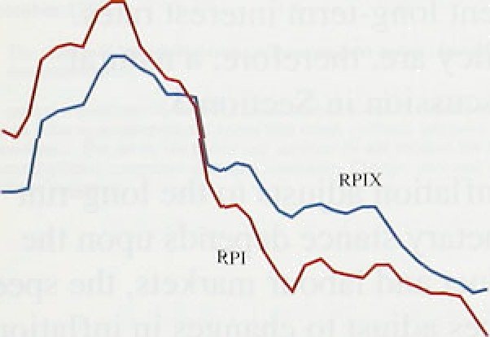interest payments, has the property that changes in

" monetary policy designed to reduce inflation actually

, raise recorded inflation in the short run. But whichever index is chosen, it wJlJ be necessary to examine its

, movements carefully in order to see whether they are consistent with the long-run objective of price stability.

Inflation is a monetary phenomenon, and it is monetary policy which determines the rate of inflation. The lags between changes in monetary policy and changes in inflation are known only imprecisely, and will vary with the state of the economy. That is why monetary policy is set in relation not to the current rate of inflation but to inflationary trends over the next year or two.

To assess these trends it is vital to know the starting point. Inflation is a rise in the general price level, and RPIX, like all price indices, is limited to a particular set of transactions. So to reach a judgement on the current level of underlying inflation it is necessary to examine a range of price indices and to analyse why they have moved in different ways. Section 1 examines a variety of measures of inflation. As well as measures such as underlying and core inflation derived from retail prices, these.include indices of producer prices—in both the domestic and overseas markets—and the price deflators for output and various types of expenditure in the naaonal accounts.



The data presented in Section l concern past changes in pti . future changes will, in the short run, reflect not opiy..tme monetary stance hut also the dynamics of ae

###### ‹pass anarchy changes in.costs. are translated into the

prices of marketed goods and services. An analysis of these costs—unit labour costs, import prices, profits and indirect taxes—provides additional information on the dynamics of inflation in the short run, and SectiOfl 2 discusses how costs of production have changed over the recent past. It provides a stepping stone from the description of past changes in prices to an analysis of the future trend of inflation.

Section 3 describes how monetary and real factors interact to determine the way in which inflation evolves over time. Expectations of future monetary policy— short-term interest rates—will determine the rate to which inflation is expected to tend. But shocks to monetary policy will alter that rate. Hence monetary developments—both current and anticipated—are crucial to an analysis of the future behaviour of inflation. Fiscal policy is important in influencing expectations of future monetary policy and, for this reason, may affect current long-term interest rates.

Monetary and fiscal policy are. therefore, a natural starting point for the discussion in Section 3.

The path along which inflation adjusts to the long-run rate implied by the monetary stance depends upon the state of demand in product and labour markets, the speed at which wages and prices adjust to changes in inflation and the exchange rate, and shocks to real demand,

output and employment. These short-run dynamics of the inflation process will determine whether the rise in prices that will result from the depreciation of sterling since last summer is more than offset by the continuing downward pressure on inflation coming from the depressed state of aggregate demand and the labour market. The Bank’s judgement on this issue is contained in Section 3. The conclusions of the Report are stated in Section 4.





Table I.A







**Gonsentional measures of inDatlon**











Inflation is a continuing increase in the general level of prices. Price stability means that this rate of increase is sufficiently small, and is expected to remain sufficiently small, that it has no material impact on the decisions of households and businesses to spend and to save. In this sense, inflation does not refer to the rise in price of any

one particular basket of goods and services, If all prices were to rise at the same rate, then there would be no ambiguity about the measurement of inflation. But relative prices change all the time. As a result, it is unwise to rely on any single index as the only guide to inflationary trends in the economy. For the purpose of assessing past performance against a pre-announced target, however, a well-defined price index is desirable. And RPIX, which is the index in terms of which the Government’s inflation target is specified, is as good as any, and better than most. But in order to assess developments in inflationary pressure it is important to examine a wide range *of prices.* That is the starting point for this Report.



2.6

2,2

2.8

3.8

I.8

z,8

4.?

3,4



### 1 Re es

###### Both headline and underlying inflation are conventionally reported as the change in prices over the previous twelve months. Neither measure captures more recent changes in inflation. Table l.A shows the increase in these two price indices over three-month periods. Clearly, such measures depend upon seasonal adjustment—the prices of certain goods, such as fresh

, fruit and vegetables, vary according to the time of year.

But the figures in Table 1.A are rather robust to the particular adjustment employed.

Short-run headline inflation has been below the

twelve-month rate-2.2% a year compared with 2.6& in December. By contrast, the short-run measure of underlying inflation is marginally above the twelvmmonth rate-3.8& compared with 3.7%—and has risen in each,of the last three months from a low po’Ht of 2.7% in August.

**Thg lbwdown** in retail price inflation has been broadly

shows ihst the delve-month rate of

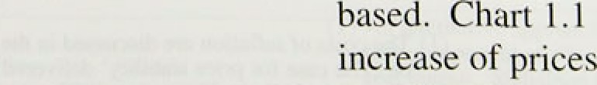

**o1both.gnods** aad services has falien over four pementage points.

Int1aticn Report: Ftbruary 1 993

Goods price inflation is currently 2.2&» and.servic‘e.price inflation 5.6&•. And in .the service sector!the more recent short-nin measure of inflation 1s below the. twelve-month rate (Table I.A).

It is natural that different sectors of the economy experience different rates of increase of output prices. Such differences reflect changes in relative prices.

Since there is no unique basket of goods and services with which to measure price changes, it is not always easy to disentangle changes in the average price level from changes in relative prices. Indeed, this difficulty, especially when inflation is variable and unpredictable, is one of the main costs of inflation.( Differences in inflation rates among sectors reflect a number of factors: differences in productivity growth rates, in cyclical behaviour, and in the degree of competitive pressure.

The division into goods and services is a rough attempt to examine the degree to which competitive forces, especially from overseas, have affected the rate of disinflation. It is also useful because disinflationary forces are likely to work initially through goods markets. Changes in services prices tend to lag behind changes in goods prices, reflecting their greater labour input, and their lesser exposure to international competition.

A more systematic examination of the impact of competition from overseas is contained in the February 1993 Quarferfy *Bulletin.* This demonstrates that the slowdown in inflation has been more rapid in sectors where output is tradable. The difference in the inflation rates between tradable and non-tradable sectors is unlikely to disappear. Inflation in non-tradables has exceeded inflation in the tradable sector for sixteen of the eighteen years for which data are available- comparable data are unavailable for earlier years owing to changes in the components of the RPI. Lower productivity growth is one important factor behind the morg rapid rates of inflation in the non-tradable sector. Similar developments can be observed in many other industrialised economies.

Some countries—including the United States and

.Canada—prefer to assess the degrele of inflationary pressure.by reference to a measure of ‘core’ inflation. The construction of a ‘core’ rate of infiadon involves stripping out of the **RPI** .items Which **are** volatile and might obscure the underlying yend in inflation. .At first sight such, an..approach, appears attfacti.ve, :ând there!is a'





**Chart 1.2**

**Measures of *core’ inflation**



_ „

197879 8081 2 B3 8d.8S M 87 88 £9 9U Vl 9?



Chart 1J

I\Measures **oF ‘core’ inflation**

Pcmenuige chengm ea z jeer earl ter

Chart 1.4



**Administered and retail price inflation**

case for excluding certain components, such as mortgage interest payments, on a consistent basis. The argument for excluding other items from the index on *a priori* grounds is less strong. And there is a danger in

excluding items simply on the grounds that their price has changed relative to others, a practice which could lead to systematic biases in the measurement of inflation. An analysis of a variety of price indices is, therefore, preferable to reliance on a single *ad hoc* measure of ‘core’ inflation.(

lt is also unclear whether, on average, there is any significant difference between 'core’ inflation and underlying inflation, defined as the rate of increase of RPIX. Chart 1.2 plots two measures of ‘core’ inflation based on RPIX from 1978 to 1992. The first excludes food and energy. The second additionally excludes local authority taxes and VAT. There are very few periods in which the differences between the ‘core’ series and RPIX are very significant, other than at times when VAT was changed (notably 1979 and 1991). Since mid-1991 the ‘core’ inflation measures have, as shown in

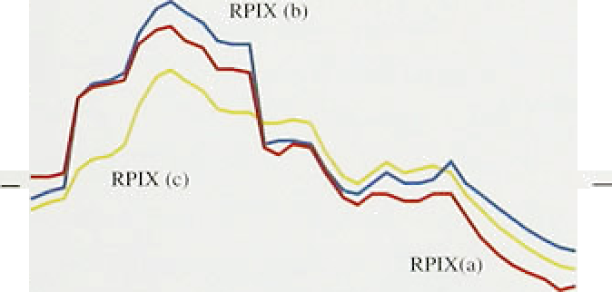

,

Chart 1.3, been higher than underlying innation.

Another reason for wishing to disaggregate the RPI is that it includes prices set by the public sector and the newly privatised utilities. Chart 1.4 shows that, over the longer term, changes in these ‘administered’ prices have tended to lag behind changes in retail prices. In pan, this is because the prices charged by utilities are

° regulated according to a formula based on past changes in the RPI. This lagged response meant that the prices set by some utilities continued to rise sharply until the second half of 199 l or the first half of 1992 (see Chart 1.5). More recently the rate of increase of administered prices has fallen below that of the RPI as a whole.

The danger in stripping out too many items from the  " RPI—housing, food, energy, indirect taxes, administered

_ prices, .and so on—is that the resulting index is not representative of movements in the average price level.

“ For this reason the Bank has constructed an RPI-based

„ measure of inflation—the ‘Housing-adjusted’ RPI (or

###### He index) which replaces the mortgage interest

" payments component of the RPI with an alternative

###### _ , rneasiire of owner-occupied housing costs. This may be useful as an addition to, not a replacement for, existing

.° measures of inflation. The alternative measure is based

(I). An alterñauve approarhas to **define** a behavioural **conceprof“'core'** inflation as





**real.output:** ..Xtatistieil tiictbods to-idenufy

C“hurt I.S

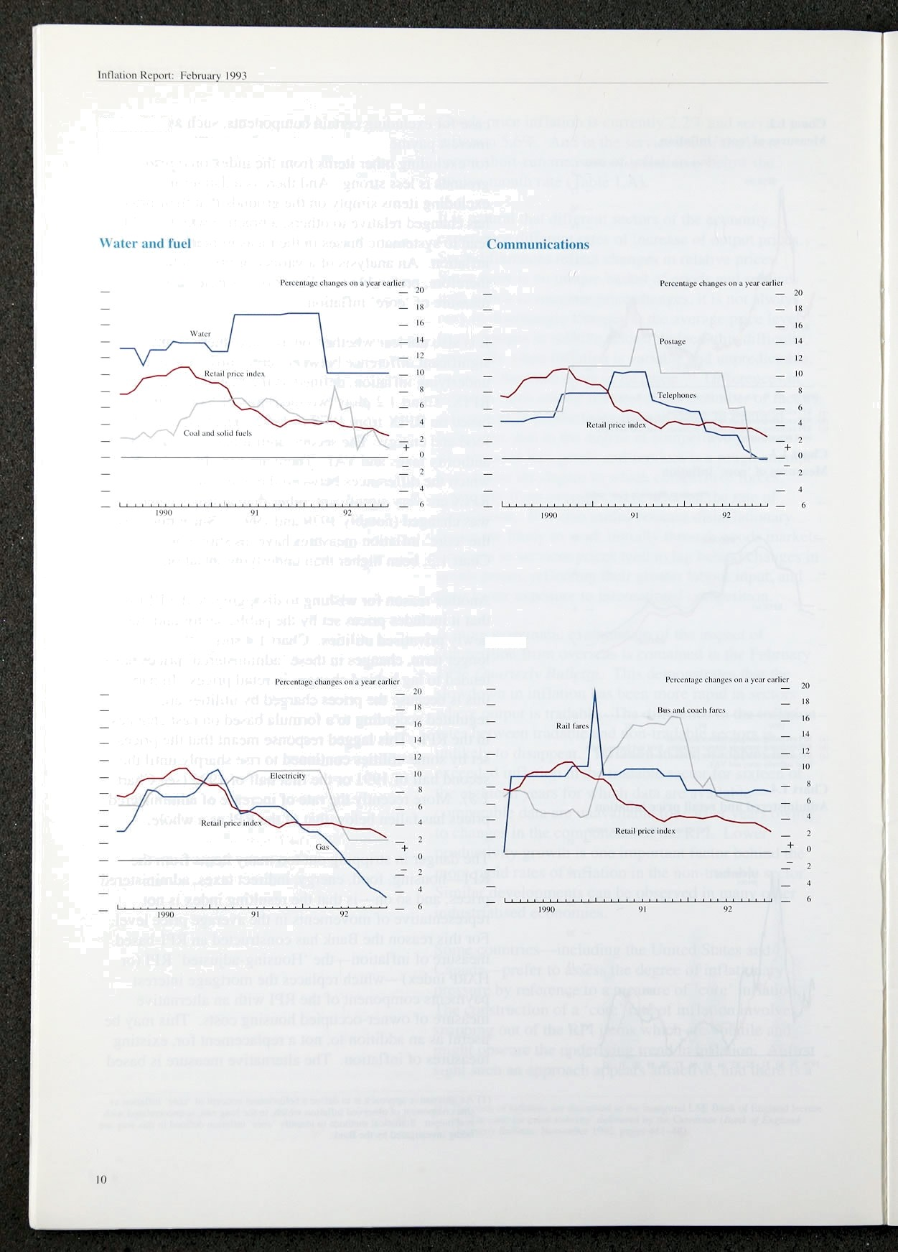

Recent cliiinges in ‘administered’ prices

Travel

on a user-cost approach which attempts to adjust for the degree to which house purchase is both a consumption and an investment decision. Its construction is described in the box on the following page. The user-cost iS



.

i!

defined as the cost of servicing a mortgage, plus th opportunity cost of equity tied up in housing net Of capital gains on the house, and depreciation **and tunnfTlg** costs. The measure will vary according to the assumptions made (especially about the opportunity cost of capital). But the HARP index shown in the box appears to perform well as an indicator of inflationary pressure. It rose earlier in the late 1980s than did the RPI. More recently its rate of increase has also fallen further. At the end of last year inflation as measured by the HSRP index was one percentage point below RPI

inflation—at around l'/i% a year.

One further, and important, RPI-based index is the Tax and Price Index (TPI). It aims to measure the increase in gross income which is required for taxpayers to maintain the purchasing power of net income, taking into account not only rises in prices (which incorporate indirect taxes) but also changes in direct taxes. The TPI was first published in 1979 when direct taxes were reduced and indirect taxes raised. A switch from direct to indirect taxes has the effect of raising the RPI even though the real purchasing power of net of tax earnings is unaffected. The TPI is designed to capture this effect.

As such, it is an appropriate index with which to deflate average (gross) earnings in order to measure the real value of wages to employees. It is not, however, representative of the population as a whole. The highest and the lowest income groups are excluded from the calculation of the index which is constructed from data on household incomes drawn from the Survey of Personal Incomes. Since 1979 the TPI has risen by around 17% less than the RPI (although both indices have more than doubled over that period). More recently, TPI inflation has fallen slightly more rapidly Can RPI inflation from its peak of almost l1&o in October 1990 to only 1.5% in December 1992.

# 2 a n

##### Pmñucer price indices (PPIs) measure the prices of

goods bought (input prim) and sold (output prices) by

**manufactiums.** The:output price index measures the ':ñbanges in:the prices of gooda: destined for the:home



lut1;iiion Repton : Pehruiir)' I '2')3

**The treatment of owner-occupied housing costs in the RPI**

The RPI is intended to measure the cost of purchasing a representative basket of goods and services. It includes expenditure on consumption only; expenditures on investment or saving are

excluded.

Around 11 to of household disposable income is spent on housing. services. Rents paid by .tenants—in either public or private housing—are straightforward to identify and have been included in the Index in some. form since 1947. For owner-occupiers, however, the task of identifying expenditure on housing is more complex. Houses yield capital gains (and losses), and have much longer lives than other goods in the RPI. So home-ownership is t›oth a consumption of housing services and an investment in a physical asset.

Owner-occupied housing costs were first included in the Index in 1965'. following the recommendation of the RPI Advisory Committee (RPIAC). Notional rents were calculated for owner-occupied properties based on rents for similar properties in the private sector.

But rents in the controlled private market did not provide a good guide to the rental equivalent of owner-occupied houses, and the calculation wus

changed in 1975. Following the report of the RPiAC in that year, mortgage interest payments (MIPs) were used as an index of owner-occupied housing costs.

The weight attached to MIPs was originally calculated using data from the Family Expenditure Survey (FES). But a further RPIAC report in 1986 noted that FES weights were exerting an upward bias on the RPI (because the ratio of endowment to repayment mortgages. was rising), and that increasing amounts of finance for.housing were being used to finance consumption. Hence the construction moved. to its present,form in, which nominal MIPs are weighted as. though every owner-occupier takes.,out a standard mortgage on’a fixed share of the rfiarket value of the. property and.renews the mortgsge after a.standarci period of time.

For these.reasons!it is ofteri iiiore useful to examine changes in the RPI:.‹ii.cludi!ng .ino rtgage interést. payments. Bqt..it.is possible to go further;and pro‹iuce an alternative. measure. of.the cost of owner-occupied housing. This. is base0 on !the concept of the

‘user-cost of housing’, w.hich.is the eqiiivalent rental payment made by, owner-ioccupiers after tilting the value of a house as an in?esttnent:into account: The user-cost equals the cost of servicing p inortgagé, plus the opportunity cost.!of equity:tied up iri housing net of capital gains on. the house, anfi depreciation arid running costs. The weight of owner-occupied. housing in the index is..then given by,the user-cost multiplied by average housé prices expressed as a proportion of total household expenditure. The resulting ‘housing-adjusted retail. prices' , or!FtARP, measure of inflation is plotted. i.n the chart from 1985—92.

**RPI and** HAltP **inFiation rates**

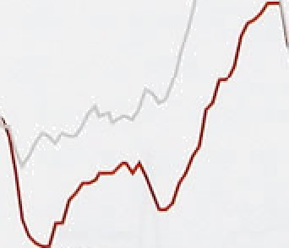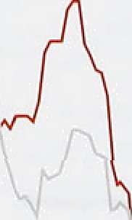

_

,





ou'ner• occupation (using v nadjusicd i-liilifit8 hiiusc pricr intlcx}. '

The computation of the HARP index dépends upon. assumptions about borrowing rates añfi alte;yative investment yields. .The.index i.n tire chan assumes that . the opponunicy cost of.capital is the:real yield from an

.But methodological problems:.remain. .First,:.only indexed g:ilt. Alternative assumptions will yielfi aroun‹i 609» of house owners have,.rñortgages. different measures .of inflation, :but the following two Second, the representative mongage is assu:med:to.be. :conc1usions.are r.obust.to.reñonable variations in non-endofimeht, whereas the proportion'of those assumptions. First, inflation implied by the endowment mortgages has grown significantly, .fsom alternative index rises steadily.from early 1986, 79c;..of building society new advances in 1970, to over wñereas the conventional RPI measure of inflation.

?09o by'the'middlé of last year. Tlii.id, fin âccountis shows unambiguous evidence of an increase.only. taken. of the fact that on about 40a of mortgages from early 1988. Second, the.peak in HneP inflation! interest rates. are adjusted annually. Most important of occurred in 1989, over one-year earIier than forlthe all; the incorporation of M.IPs into .the Index means’ **.RPI** .itself, The.eiost recent twelve-month mto ot that‘changes in. monetary policy aimed:to.redqce:. **l-biRr** inflation. is only 1'f(%. one **parcentige** point. inflation..actually Use the RPI. lower than.the headline.rate.of inflatroll.’













1gg0 9i 92 93

**Chart 1.7**

**Manufacturing export and producer price**





- 7











Innation in the manufacturing sector has fallen relatively little in the last six months. Output prices for all manufacturing are estimated to have increased by 3.5&• in the twelve months to January, down from 3.6% six months ago, and 4.5& in January of last year. Excluding the food, drink and tobacco industries—where price changes are heavily influenced by excise duties— inflation is a little lower. Chan 1.6 shows that, on this basis, producer price inflation peaked at the beginning of 1991, at 6.SP, before declining steadily throughout the year. By February of 1992 the rate had fallen to 2.8%,

since when there has been little further progress. The

chart shows that this was broadly in line with the indications given by the shorter-run measure, which fell from a peak of 7.3% in February 1991 to just 2.7% in May of that year. Thereafter it remained largely in the 2&M&o range. In January 1993 the measure rose to 2.3% from 1.8&r in each of the previous three months.

###### Within the sub-components of the index the range of price changes has been wide. At the disaggregated two-digit level of the Standard Industrial Classification (SIC), the inflation rate in the year to January varied from an increase of 6.8&o in the drink and tobacco

industries to a fall of around 3& in the office machinery and data processing equipment sector. Such wide dispersion within the index is not uncommon. There are always likely to be differences in productivity growth rates across industries, and in some industries rapid technical progress permits price reductions. This has been a feature of the consumer electronics and computer industries throughout the past decade. But there is no evidence to suggest that the degree of price dispersion has altered over the past few years, although clearly the average rate of price increase has fallen.

Throughout most of 1990 and 1991 manufacturing export price inflation remained well below the rate of increase of producer prices. But towards the end of 1991 the two inflation rates began to converge (see Chart 1.7). The lower rate of increase of export prices appears to have been associated with the appreciation of sterling in 1990, and continuing pressures on competitiveness into the

1991. But more recently, manufacturing have risen much more rapidly. A similar

in the exports of services and non-oil generally (Chart 1.8).

ted liii5eptember may lead to some **widening** of the





Inflation Report: February 1993

likely to rise more.rapidly. But this .will depend on the extent to which exporters desire. and are ab'1e, to widen margins by increasing their sterling prices, or whether they maintain sterling prices and increase volumes as the foreign currency prices of UK exports fall. The fourth quarter data suggest that exporters have begun to raise prices, although this may reflect the impact of the depreciation on patches invoiced in foreign currency. The increased profitability of eKporting should have a positive impact on export sales, and, if sustained, should 1ead,to greater investment in export-intensive production.

* 1. **Domestic deflators**

GDP and its.components are calculated both at current prices, and also in real terms, at the prices which prevailed in a base year. The ratio of these two measures is a price index, the *deflator,* which converts the current price measure into a volume measure.

Table I.B

**Domestic deflators**

|  |  |  |  |  |
| --- | --- | --- | --- | --- |
| GDP | Consump- | invest- | Govern- | Exports Imports |
|  | \ion | menu | ment |  |

|  |  |  |  |  |  |  |
| --- | --- | --- | --- | --- | --- | --- |
| I991Q1 | 8.0 | 7.2 | 2.2 | 9.2 | 0.5 | -4.3 |
| Q2 | 6.11 | G.7 | -o.4 | 8.4 | I.4 | -3.i |
| Q3 | 5.3 | 6.9 | -1.8 | 7.1 | 0.8 | 0.1 |
| g4 | 'i.2 | 6.4 | -2.5 | 7.5 | -0.’7 | -0.2 |
| l992Ql | 5.2 | 6.2 | -4.2 | 7.5 | 1.4 | 0.5 |
| Q2 | 5.5 | 5.6 | —4.6 | 6.1 | -0.1 | -1.1 |
| Q3 | 45 | 4.6 | -3.9 | 6.7 | -2.1 | -2.4 |



SewonalTy adjusted annuaTised rates

|  |  |  |  |  |  |  |
| --- | --- | --- | --- | --- | --- | --- |
| @2 on QJ | 6.7 | I .8 | -4.8 | 6.0 | -0. I | -4.6 |
| Q3 un QI | 4.4 | 2.3 | -3.2 | 6.2 | -3.6 | -3-9 |

A comprehensive measure of domestically-generated inflation is provided by the rise in the GDP deflator which excludes import prices. Because the deflator is derived from national accounts data it is available only with a lag. The latest figure is for the third quarter of 1992. The annual rate of inflation, as measured by the GDP deflator, was 4.Sta at that point—slightly higher than RPIX. It had peaked at over 99r at the end of 1990.

Table I.B opposite shows a disaggregation of the GDP deflator by category of eKpenditure. The upper section of the table shows twelve-month growth rates, and the lower section shows annualized one and mo-quarter gr*ow*th rates using the most recent observations.



Although the GDP deflator fs measured at factor cost (ie it excludes changes in indirect taxes and subsidies), the deflators for the expenditure components are qsually measured at market prices. ..Such deflators carr give a misleading picture of underlying inflation in each expenditure category, as ti err moVements can.be dominated by indirect tax changes, s*ch::as the VAT1 increase in 1991, and.the change from domestic rates to! the Community **Charg**e i!n 1990.. **Hence** in the:.table opposite the figures. Bank. estimates of the deflators. measured at factor’cost. ’ ”

The @duction!in infladon during 1991 ertd 1992 oan Jargely be attributed to tke weakness âf the investment and oeport,pnCe deflators. In:vestment goods pncns





have fallen continuously from their peak in the first quarter of 1991 while export price inflation has remained low or negative thmughout the past two years. Weak demand at home and abroad may have been partly responsible for this. More recently, the consumer spending inflation rate has fallen back, echoing developments in RPIX. ln the public sector, inflation remains much higher than in the other sectors. This reflects the higher proportion of wage costs in the government expenditure deflator.

### 4 S a

This section has examined a wide range of price indices. The consistent message is that inflation has fallen sharply over the past two years. The decline was particularly rapid in those sectors most exposed to competitive forces, but there is also evidence of a substantial fall in the rate of increase of administered prices and prices with a high labour cost element. The rate of progress began to slow towards the end of 1991—initially in the manufacturing sector, and subsequently in retail prices —but it has continued, so that rates of increase of most prices are at their lowest for some years. Short-run measures of inflation have recently begun to point upwards, but it is as yet unclear whether this is anything other than a temporary phenomenon. Such a judgement requires a more detailed look at forward indicators of prices. These are examined in subsequent sections.





In an accounting sense, the price of any particular service or commodity reflects the unit costs .of its seller and the mark-tip applied to them. As noted above, this implies no necessary long-run causality from costs to prices: both reflect underlying real and monetary shocks. But in the short run the dynamics of the inflationary process mean that changes in costs are a leading indicator of changes in prices. For this reason we now examine the recent behaviour of both domestic and imported costs.



US ill yort prict **inf1ati‹›n** : ncn-cil g‹›t›ds

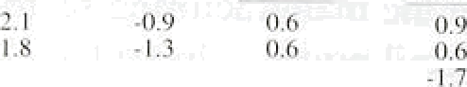

Q2

-*.4

-5.I

-I.:

.t›.g





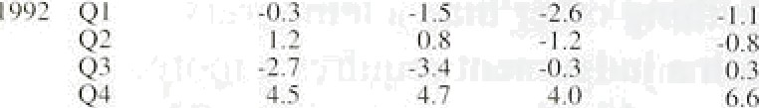



increases in prices may be broken down into increases i.n:

1. the prices of inputs of goods and services not themselves included in the index. At the aggregate level the most important such prices are those of imports, both of raw materials and finished goods and services;
2. unit labour costs;
3. margins (at retail and wholesale level);
4. indirect taxes.

We consider these components in turn:

**’l“ahle 2.Ii**

**UK inip‹irt price inflation: total**

Percentage chsn c on previous qusncr

#### 12st f o



Import prices in the United Kingdom have fallen slightly since 1990. This reflected a number of factors,. including falling commodity prices, lower,growth in

1990 QI

Q2



0.9 L0

0.3 1.9

-3.8 l.1

0.7

competitor countries, weak demand in the United Kingdom, and the strengthening of sterling against the

Q4

199J Q I

Q2

Q3





Q2 Q3



0.4 -5.6 I ?

- I.9 0.4 - I.6

0.9 6.0 2.0

-0.4 5.0 1. i

1.0 -ñ.3 -I.7

- I .6 - 1.3 - T .3

0.9 1.8 1.2

-2.3 7.0 0.2

dollar that took place in 1990-91. Towards the.end. of

last year, however, prices began.to rise sharply—by

**HfotJf2d $O2',gOOdS DIGS Ij2 t)2R bOUft)2 QUBft8f Offa**

average, to stand almost 5& higher than a year earlier

(see Table 2.B), Prices of foods and basic materials rose

.by around 4,5% in.the. quarter,.but.the incrpase in the price of manufaefures:was rather greater, at oVer fi&. This mainly reflected increases in the price of finished maiiufaetures (see, Table 2.A specially cars, which rose’ by.almost .9%.



Developments in impori prices have a significa nt impact on manufacturers’ input prices. Within the official input price index for materials and fuels purchased by manufacturers, around 60% is accounted for by imports of materials, while petroleum fuel products account for a

further 6%.

**Charl 2.1**

**Sterling exchange rate, 1990** - **t00 '*'**





Reflecting the weakness of import prices, manufacturers’ input prices fell during 1990 and 1991— by 0.3% and 1.1% respectively. Excluding inputs to the food, drink and tobacco industries the falts were raiher

i » greater (0.8% and 2.3% respectively). The weakness continued during the first three quarters of 1992, but

'" during the fourth quarter input prices rose sharply—over

_ , 4% for all manufacturing. A large part of the fourth quarter increase was concentrated in October and

"'" November, but the relatively small rise in December has

_ been followed by a I.5% increase in January.

iQ9O 91





**Table 2.C**

 **The sterling exchange** rate‹•›

*'' The exchange mite*

Movements in nominal exchange rates affect the sterling price of imported goods and services. If these were traded in perfectly competitive world markets. a given depreciation of sterling would be reflected in an equivalent increase in the domestic price of imports, and a common price *l,evel* when expressed in a common currency. In practice imported goods and services are not always traded in all countries at the same price when expressed in a common currency. The more homogeneous the product and the more competitive the market the more likely it is that changes in exchange rates will be passed on entirely to prices. This is most apparent in commodities markets in which a broadly standard product is traded by many firms. But in markets where firms can exercise a degree of price discrimination—such as the markets for finished manufactured products—changes in exchange rates may be absorbed. at least in part, in the margins of

30 June IS Sep mbcr 31 Decemkr 5_February

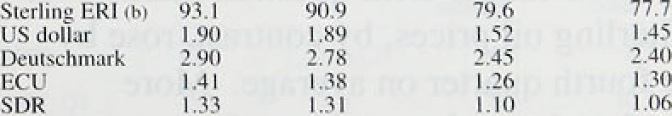



price-setting firms. ’

The size of the recent depreciation is clear from

Chart 2.1 and Table 2.C. Before mid-September there had been some very gradual decline against the European currencies, but the most marked variations in sterling’s value had been against the dollar. Since the suspension of ERM membership, sterling’s fall against the dollar has been greater than its fall against the deutschmark and other European currencies. The fall against the dollar between 15 September and the end of December amounted to almost 20%. By S Febniary

17

lnl\onRepnn: Febmay lU90 _

C’hart 2.2

sterling had fallen by a further 4'/i&. The depreciations

SlerliTtg and hDR commodity prices„ ,q, against the deutschmark and the ncu have been much

"' less: 14% against the former and 6&• against the latter.

i , Taken together these changes imply a decline in the SDR rate of over l99• in the past five months.



Ql Q2 Q3 Q4 Q I Q2 03 tt4 Q l Q2 Q3 Qt



Sterling and SGR mil price ':'›



— 30

In SDR terms the Economist All-Items index of non-oil *commodity prices* fell by 4.6% in 1992 as a whole, and by I '/i% in the final quarter, to a level almost 29% below the level in 1980. The prices of industrial materials were particularly weak. The fall in prices over the decade reflected an increase in supply relative to demand. New reserves were discovered .faster than old reserves were exhausted. Demand has gradually switched away from manufactures towards services, and the efficiency of the use of materials has risen. After 1990 the fall in prices was accelerated by the slowdown in world activity growth. More recently, however, there have been some signs of recovery. During the final

quarter there were increases in the food and agricultural components of the index (in SDR terms), although industrial materials prices fell further. The All-Items index has now risen by 10&r from its low point in October. Sterling prices have risen even more sharply—by 14'/zoo in the fourth quarter, although for the year as a whole sterling prices *sit II fell* by 19 (see Chart 2.2).



qi Q2 O3 A Ql Q: U3 q‹ Or Q2 O3 B

‹ «› k1casurod by cIr+se-dated Brcn I crude.

Table 2.D

lnt4ation in the G7 economies

F'crccniagc change on a year earlier



Consumer prices

Unncct Sraces 5.3 



1.9 2.3 1 i8 1.0

The price of oil (as measured by close-dated Brent crude) fell to an average of $19.30 per barrel in the fourth quarter, down some 90 cents from the third quarter price. Prices weakened during the fourth quarter reflecting disappointment following the November OPEC meeting which agreed only a marginal cut in the first quarter production quotas. The milder than expected winter, thus far, and continuing overproduction by OPEC, combined to push prices doyen:further, notwithstanding some longer-term question marks over

Fmncc 3.4

Un›tud kingdom 'ray 8..'i G7 average (by 5.0

UnitTd Snores 3.b

; 0.4



United Kingdom 6.1

G7 av<rag< r#› 2.

4.3 4.fi' 3.5 3.7

1.I 3.1 2.7 2.1

5.6 5.6 3.3. 4.9

^L? 3.3 4.2 3.7

3.t 3.3 3.0 2.7



-I .6. *-I .3* -1.4 -1.5

’2.0 2.0 i:0 ’ O:S’

-3.0 -1.I. -0.9.

0.9 2:7' l.'.7

4.S 3.6 3J 3,4



Iraqi exports. Sterling oil prices,.by contrast,.rose;by over lfi% in the!foiirth.quarter on average. More recently, dollar prices have shO.WH..signs of recovery

.prior.to the.February OPEC meeting.





at.amund 3 (see Tgble’2.D.). As ln the first:half of,ilie: year, inflafioii remained high„est id Italy arid Germany (where the f:all in inf1aiip:n diring the year largely

**Chart 2.4**

**Inflation in the G7**





**lMenhAmmce**



" MW — 0.0

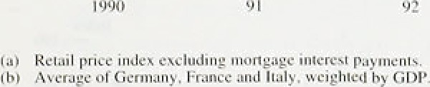

**Table 2.E**

**Contributions of earnings and productivity** to unit wage costs

1. Wbole economy

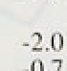

|  |  |  |  |  |
| --- | --- | --- | --- | --- |
| 1990 | 0.6 | 0.3 | 9.7 | 10.0 |
| Q2 | -J4 | -3J | y.9 | 8.8 |
| Q3 | -2.2 | -3.6 | 7.9 | 6.8 |
| 'Q4' | -J.7 | -3.8 | 7.2 | 5.5 |
| )992 Qt | -1.4 | -3.1 | y:g | 6.6 |
| Q2 | -0.6 | -2.6 | 6.2. | 4.3 |
| :Q3 | -07 | -?.2 | dd: | 3.0 |



Period Outyut gaiployniwtt Wages and Llzfit wage



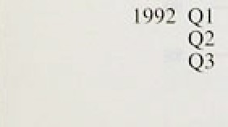





Q? •6.6 -6.4 8:3. I0:0

reflected the dropping out of the twelve-month comparison of the increases in indirect taxes in July 1991) and lowest in Canada (where there has recently

been some slight increase} and Japan. UK inflation

remains above the average, but has clearly converged rapidly over the past two years, to a rate broadly in line with the average of the other three major European economies (see Chart 2.4).

Manufacturing price inflation has been much more subdued across most of the G7, especially in France and Japan where producer prices have fallen throughout the year. Although UK producer price inflation appears to have converged less rapidly on overseas rates, care must be exercised in such comparisons because producer price indices are less internationally comparable than consumer price indices. In particular, producer price indices in other countries often incorporate both input and output prices. When there are sharp changes in primary commodity prices producer price indices in different countries respond in very different ways.

Although data are still incomplete, export prices in most of the major overseas economies seem to have remained weak in the second half of the year (after barely rising in the first half). In local currency terms US export prices fell in both October and November (to a level 0.3% below a year earlier). In Japan there were large monthly falls in September and October, only slightly reversed in November. Consequently by December local currency Japanese export prices were 3% lower than a year earlier. In Germany a slight increase in November was insufficient to reverse the small fall in October.

2.2 Unit labour costs

Unit wage cost increases, in both the economy as a whole and in the manufacturing sector, have been on a downward trend since the beginning of 1991. This has resulted from both a rise in the rate of growth of productivity and a decline in the rate of increase of earnings (see Table 2.E).

###### The gins in productivity from labour-shedding have been significantly larger in this recession than in the jfrqq{vtpVs two (see Chart 2.5 over the page). In those



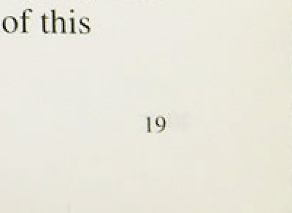

*›o..psoiom output growth initially fell more **rapidly tbaa**

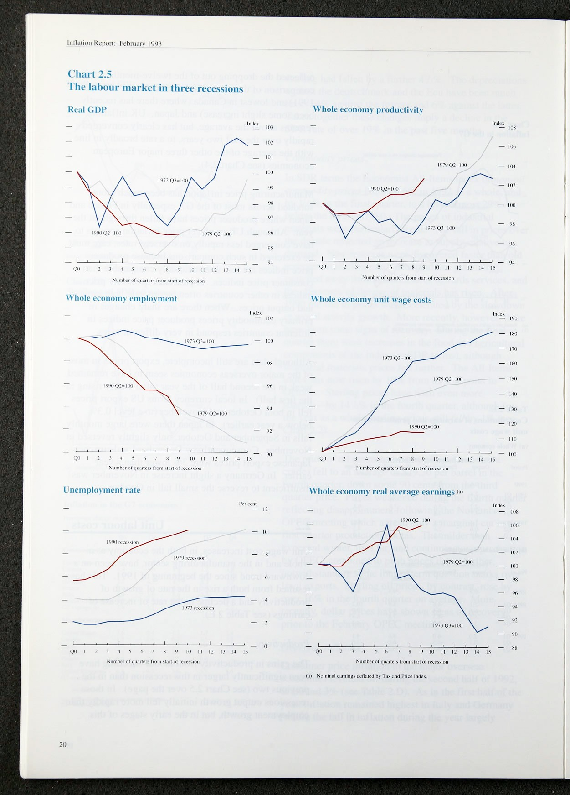



recession the growth in employment decl ined in line with the growth in output. This difference may reflect a fall in the costs associated with hiring and firing, but

perhaps also a more rapid downward revision of’ expectations of output growth on the part of producers.

Reflecting the fat!s in employment, uneicploy ment has also risen rapidly. More worryingly. thc unemployment rate has risen to a higher level during each recession, from which it has only partially declined.

**Charl 2.ft**

h **Iiinut.icturing an‹l** o **h‹ile** econorns **}iroduci iviiy**



The rise in productivity has contributed to the slow growth of unit labour costs, which has remained signiflcantly lower than in previous recessions— reflecting also the lower rates of increase ot’ prices and earnings. But real wages—as measured by whole economy earnings deflated by the Tax and Pi ice Index—have grown steadily throughout the

recession.

In manufacturing, movements in employmenl and productivity have been more cyclical than in the economy as a whole (see Chart 2.6). Since the peak in



— output in the second quarter of 1990. Overall labour

* › productivity has increased by 2.6°/ . and in manufacturing by 4.69r. Given the more rapid decline

_ in output in the manufacturing sector than in other

_ , sectors, it is clear that the relatively more rapid

, productivity growth is accounted for entirely by the sharp falls in manufacturing employment, which fell by

680.000 (l 3% of the employees in the sector) between the second quarter of 1990 and the third quarter of 1992. Outside manufacturing the corresponding figure was 880,000 (59c of all non-manufacturinp• employees).

More recently productivity growth has picked up. rising  to 2'/ % in the year to the third quarter of 1992 in the

economy as a whole, and to over 4Vc in manufacturing. As in previous cycles employment has continued to decline although the fall in output has slowed

 considerably. Indeed. the fall in employment accelerated during 1992. In the service sector employment fell by l '/i% in the third quarter, after falling at an average quarterly rate of 'his during 1991.

In the manufacturing sector employment fell by almost 3% in the third quarter, compared with average quarterly falls of 1.8% during 1991 and 0.7% in the first half of the year. Although the pace of decline eased a little in October and November, the fall in the fourth quaner is likely to approach 2%.

InBuiion Repori: February 1993

Chart 2.7



**Increases in RPI and** wage **settlements**

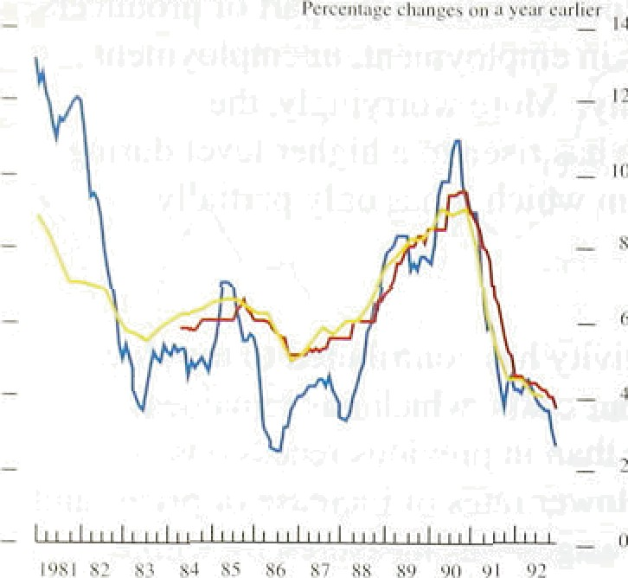

Chart 2.8

Increases in manufacturing **wage settlements**

und earningst:





1981 87 8] 8# € 56 87 88 #9 OO 91 92

**Increases in** whole economy **wage** Settlements and earnings‹•›





*Earnings and settlements*

There are two main sources of data about the growth in UK wages, relating to settlements and to average earnings. Settlements data usually refer to the percentage increase in the basic wage for the

lowest-paid grade in the settlement group and typically cover only those agreements struck in the reference month. Earnings data include, in addition to basic wages, overtime pay, bonus payments, shift pay and other elements of wage ‘drift’; they measure the average rate of growth during the past twelve months. Data on settlements across the whole economy are provided on a monthly basis by Industrial Relations Services (IRS). The series is a three-month moving average of annualised settlements. Data on settlements in manufacturing industry are produced monthly by the CBI based on a survey of around 1,200 personnel directors. This series is a hybrid, because it asks about the impact of the most recent settlement on average earnings (including agreed increases in bonuses and merit pay) over the next year.

Since the beginning of 1989 there.has been a very close relationship between whole economy and manufacturing settlements, on the one hand, and retail price inflation, on the other (see Chart 2.7). Whole economy settlements halved from over 9% at the end of 1990, to just 4'/the by the beginning of 1992.

Thereafter, as for retail price inflation, the profile flattened out, such that whole economy settlements were 3.6% in the three months to December. In the manufacturing sector settlements fell rather more slowly than in the rest of the economy. After running at around 9& through most of 1990, manufacturing settlements fell below 69» by the end of 1991 and have since declined to below 49c.

Since the peak of settlements and earnings growth in 1990 a gap has opened up between these two series, with settlements falling more rapidly. The relationship between the two series is far from.precise, reflecting the differences in measurement, coverage.and timing. But settlements do appear to contain some information about the future course of earnings growth. Chart 2.8 shows..that, in both manufacturing an the whole economy, earnings gro.wth.tetids to:exceed.’seitlements,: and that the.divergence betw n the two can be quite marlmd, particularly whep'sett1etcegts are changing



growth may sJ‹iw further—but therc is also the possibility that it simply foreshadows the restoration of the normal gap between the two series.

Nevertheless, underlying earnings growth has continued to decl ine. In the economy as a whole. earnings growth fell from a peak of’ l0’/‹°Z‹ in the year to July 199() to 5% in the year to November 1992. In manufacturing earnings growth fell from 9'/ % in December 1990 to 5'/•% in November. The deceleration in manufacturing earnings growth has thus been less marked than in the economy as a whole—a pattern which was also exhibited during the last recession. This may partly reflect the greater strength of insiders’ in manufacturing, who are better ahle to maintain real wages in recession. But the counterpart is to be found in the more rapid shedding of labour in manufacturing.

* + 1. 3 B ne a s

In assessinh short-run changes in inflation it is useful to consider the ratio of prices to costs which reflects the extent of current pressure on profit margins. There are

'"’ - two general approaches to such calculations. First. national accounts data can be used to look at the ratio of

'' total profits to total costs. Second. an output price index

— • or deflator can be compared with an index of costs.

Each method has several variants.

One measure of profit margins can be obtained by

„ „, „ comparing total profits (net of stock appreciation and

capital consumption) with total costs (primarily labour

‹ » • » » ‹ ›• ›• ‹ “ and import costs) using national accounts data. On this

measure, profit margins for the whole economy are estimated to have declined during 1989—90. and then remained broadly flat until the end of 1991. In the second quarter profits are estimated to have increased by 9%, with a further rise of l.5Vo in the third quarter.

Since costs remained largely unchanged margins are estimated to have risen again (see Chart 2.9). The fall in margins in the current recession has been much less marked than in the recession of the mid- 1970s, but not dissimilar to the decline of the early 1980s. The comparison with the early 1980s is, however, distorted by the inclusion of profits from the North Sea which were buoyant at that time. Excluding such profits, the present decline in margins can be seen to have been much less marked than in the early 1980s.

23

 

i I tic I ti i yrs ’ iuii rgi us

An e.stimate of’ profit margins in manufacturing may be

"'"'"' consti’ucted by comparing producer output prices with. an estimate of costs combining labour costs and producer input prices, using weights based on 1984 input-output tables (Chart 2.10 and Table 2.F). By this

, , measure the price-cost mark-up has been broadly sustained through the late I '980s and early 1990s. This has principally been achieved .by cost restraint since output price inflation has been falling significantly in

the past two years or so. 

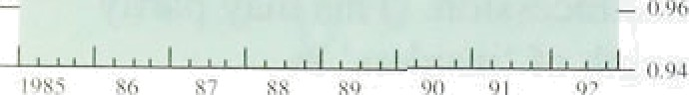Assuming that rhe costs of exporters of manufactures are identical tr› those of domestic manufacturers more generally, it is possible to calculate a measure of export margins by replacing the producer output price index with the average v3lue index (AV I) for exports of manufactures. On this basis margins on manufactured exports are estiiiiated to have fallen signi.ficantly from their peak at the end of 1986 (see Chart 2.1 l). The. fall probably i effects the impact of sterling’s appreciation during the late 1980s, and may be revei sed—at least in part—by stei’ling’s depreciation.

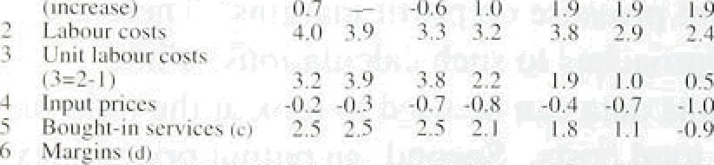





**1f»nut'ncturin;t import and expnrt margins**

Ideally, a measure of i.mportei s margins would compare the final sale price of imports within the United Kingdom, with total production and distribution costs. Howevei, information on the. final sale price of imported goods is rlot available. But it is possible to compare the sterling price of U,K imports of

manufactui es (based on the AVI), wi!th.,an. estimate of the production costs of imports based largely on overseas unit labour costs (see Chart 2..1 l). Using the AVI, as opposed to domestic sales pfices, means

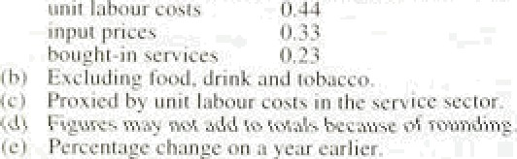

that the measure does not include distributors’ costs and margins in the United Kingdom, but it does include shipping and insurance costs to the United Kingdom.

“ Chart 2.1 I shows tliat'.i.mporters’ marginsl fell by over 

* 9. p,ercentage points..between. 1590 Q3. and..1992 Q3, to
* their lowest level since 1'987., The we”akfiess of margins

_ , on this .measure sug!gests'that i.mp.orters may have little

_ further scope to absorb mu‹ih of the recent depreciation, a!lthough.if they wish.to rfiaifitain. sales..of impons: they

“ may be forced to do so., An increase iri the relative

°’ price of irñports would be iikéliy to encdur e'UK

* • .purchasers to switch.eKpenditure towa ds domestic

_ „ .products, alt1iough!,tfie .extent!to which:.they will do so ” "' ’! ' "' .remains to be seen:

?4



**2.4 I ndirect taxes**

On April 1 199 I the rate of *VAT* was increased frrim

I 5% to 17.5°/.. This added about 1 . I percentap•e perms to the RPI, most of which would have appeared in the

Apri I and May 1991 index numb8fS. The CSO estimated at the time of the 199 l increase that some

ñ 1.5% of expenditure covered by the RPI was datable ’.

There have been stiffle other minor changes in co vera e in *recent* year s. but these are I i kely tO have had only a marginal impact on the RPI.

Most rxri.se *clutie.s* were indexed in the 1992 Budg•et to the increase (of 4.5%) in the RPI in the year to December 199 l. However, some duties were increased further. including exci se duty on some tobacco products and on leaded petrr 1. Excise duty for vehicles in the pi‘ivate and light goods class, and for tax is. was

inci eased ti om £100 to £110 i n the 1992 Bud;iet. which also announced a reduction in the i ate of car tax ( p‹iid when purchasing a new car) from l0*/c to 5°/r. Car‘ tax was subsequentl y abolished in the 1992 Autumn Statement. This has no dii ect effect on the RPI. which excludes the price of new cars, but it will have an

indii ect effect through its impact on second-hand car prices.

In April 1990. the *€riinnioiiiri Cluirge* was introduced in England and Wales. It is estimated that the introduction of the community charge in 1990 added approximately

* 1. percentage points to the RPI. In April 199 l a rebate of £140 was introduced, but the impact on the RPI was broadly offset by the simultaneous increase in VAT and excise duties.

#### 2.5 Summary

This section has examined short-run cost pressures that might subsequently feed through to higher prices. On the labour cost front, there was a marked slowdown in the rates of increase of earnings and settlements in 1991—92, and there are now signs of renewed slowing after a period of levelling off. Emplrical models of wage determination assign a significant role to past rates of inflation, so that the further recent reduction in headline **RPI** inflation should reinforce the decline in settlements. Unemployment, too, plays a significant role in wage determination, so that further downward pressure can be expected from past and prospective labour shedding.



But past experience suggests real wages are slow to adjust. The net effect should be either a flattening-off of

25

Inflation R_epori' Febniary 1993

###### the recent downward trend in earnings growth, or a further slowdown. On balance, therefore, the pressures from labour costs are unlikely to increase in the

short-to-medium run.

By contrast, cost pressures arising from the recent depreciation of sterling have become evident in the past few months. Reflecting the recent rise in import prices, manufacturers' input prices increased by 4% between October and January. The increases might have been greater had not overseas inflation been relatively subdued. Nevertheless the rise in imported and raw material costs is likely to pass through into producers’ output prices, and thus into underlying inflation, unless producers’ margins are further squeezed. The evidence suggests that, especially in manufacturing, but also in the economy more widely, margins have held up surprisingly well in the present recession compared with earlier recessions. Producers may thus have scope in the short run to absorb such cost increases, and hence the impact of depreciation on domestic prices may take longer to be seen on this occasion than in the past.

Producers will be less reluctant to squeeze their margins if they believe that policy will not accommodate any increase in inflation.







The two previous sections have discussed in some detail the past behaviour of both prices and costs. From thi s evidence it is clear that there was a strong downward momentum to inflation prior to the relaxation of monetary policy which followed the suspension of sterling’s ERM membership. To assess the future outlook for inflation, it is necessary to judge the balance

between the downward pressure on inflation deriving from the current state of the domestic economy and the upward pressure that, other things being equal, will follow the r elaXation of poliCy. A number of factors art relevant to that judgement. Monetary conditions are the principal determinant of inflation in the long run. This section begins, therefore, with an analysis of monetary and fiscal policy. The former relates to short-term developments in monetary conditions and the latter to expectations of future monetary conditions in the

medium term. The rate at which domestic inflationary pressures adjust to the level implied by the monetary stance depends upon demand and supply conditions in both product and labour markets. Section 3.3 discusses the most recent data for real demand and output in the light of debt burdens inherited from the past. The extent to which a recovery in demand will generate short-term inflationary pressures depends on the extent to wh@h the growth of productive potential has been affected by the length of the recession. If the reduction in inflation is to be sustained, it is crucial that nominal wages and

.earnings rise at a rate consistent with price stability. The link between conditions in the labour market and the rate of growth of earnings is discussed in Section 3.4.

An important test of the credibility of a

counter-inflationary strategy is whether private sector expectations of future inflation are consistent with the stated aim of that strategy. Section 3.5 describes evademe on expectations of inflation derived from direct sure s of expectations and the expectations contained ip.gsgmp1e of private forecasts for the UK economy.

;J„ , „ , , . fleation!3.6. attempts to bring, this evidence together in

t : 3p reach a judgement about the direction in which



InfTatit›n Rcpun: ficbnJary 19+3

some two years is more appropriate. Over such a period an analysis of the behavioural influences on inflation.is: required. This section discusses the factors that determine inflation in the medium terin.

### 1 Mone a nd n

”Fahlr 3..!t

I .xpected timer-munth *t•ihnr note*





|  |  |  |  |  |
| --- | --- | --- | --- | --- |
| 7.0(› f›.58 | I›.26 | 6.14 | fi.36 | fi.40 |
| h.l9 5.74 | ;.27 | 5.18 | fi.28 | S 67 |

Ch:irt 3.1

**Implied *torward* interest rates**



21 ficp‹.





1. *liiteresf* ***rnles***

Since mid-September, official shorr-term interest rates have fallen by four percentage points and base rates have been reduced to their lowest level for nearly 15 years. But economic prospects over the medium term depend on the pass-through from official short-term interest rates to the prices of many other financial assets. So the effect of the easing of policy depends on .the behaviour of private sector agents, and their eKpectations of future changes in policy.

Inspection of expected interest rates (derived from interest rate futures prices) suggests that the markets anticipated—at most—only a further '/4 percentage point reduction in UK interest rates in the early part of this year, but that this would subsequently be reversed (see Table 3.A). German interest rates, by contrast, were expected to fall by over one percentage point by lune, and a further percentage point by December. Ecu rates were expected to fall broadly in line. By contrast, US interest rates were expected to rise by over a percentage point during the course of this year.

The structure of interest rates across the maturity spectrum offers an indication of expected changes in interest rates and inflation in the longer term. Chart 3.1 shows implied forward interest rates (derived from prices of conventional gilts) at various dates in the past five months, and demonstrates clearly the sharp change in the slope of the yield curve in September—from downward to upward sloping. This reflected both the cuts in interest rates which had already taken place, but also!the anticipated effects. of the loosening of monetary policy. For a given. maturity, the. nominal interest rate may be disaggregated.into three components: the.rea!l rate, the inflation risk.premium! and. the expected.

.inflation.rate, Assuming changes.in both the real rate. and the Inflation rate premium.to be negligible,.an. increasé in.interest.rates at the 1ong:end.of the maturity spectrum..indicates.a.rise in. expected !inflation. It is notable that.the.curve.relating to the peliod:before suspension **of.EnM** membership .intersects. with the later carves at›an horiz:on of around’ six years (see Chart3.1.): This is eonsisteAt with a pattern i.n whicli iriterest rate



Twelve-mpntb growth rates of MO, M4 and

bank and bulldtfig society lending



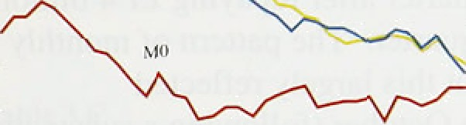

MO



Level of MO and the value of retail sales







Chart 3.4

Private seetnr set sterling recourse to banks

«ss « ai»s«• "'



cuts initially lower the RPI headline inflation rate below the rate which would have been likely had the United Kingdom.remained in the ERM. But policy is

apparently now thought likely to be looser in the medium term than it would otherwise have been, and inflation consequently higher.

1. *Monetary aggregates und credit*

Narrow and broad money growth offered conflicting signals in the fourth quarter.

Narrow money growth has remained strong for seven consecutive months. At an annualised rate, M0 grew by 6.99• in the fourth quarter compared with 5.59c in the previous quarter. By January its twelve-month growth rate, at 4.1%, was just above the One—4% target range.

The twelve-month change in notes and coin rose to 3.4&o

in December and 4.0% in January (from 2.29r in September). In part this growth may be accounted for by changing expenditure patterns (see the August 1992 *Quarterly Bulletin )* and also by the falling opportunity cost of using cash (as interest rates decline). Bank estimates suggest that up to 0.5% of the current annual growth of M0 may be the result of reductions in interest rates in the latter part of last year.

The broader monetary aggregates, on the other hand, show no signs of recovery. After falling from a twelve-month growth rate of l89o at the beginning of

1990 to around 6&o by the begjnning of 1992, M4 growth declined further—to below the 4&—8% monitoring range-in the year to the fourth quarter. The annualised quarterly growth rate—which fell from 5.3% to 2.1% during the course of 1992—points to further decline in the twelve-month rate. The slowdown in the credit aggregate has been even more marked: from over 20&o in the first quarter of 1990 to 5.2& at the beginning of 1992 md to just above 4W by the end. The fall in the growth rates of real M4 and lending has been less rapid as inflation has also fallen.

Net recourse to banks and building societies by the prisatesector increased by only £0.3 billion in the fourth qqafteq to fi2.0 billion. Industrial and commercial campanies (ICCs) and other financial institutions (OFIs)

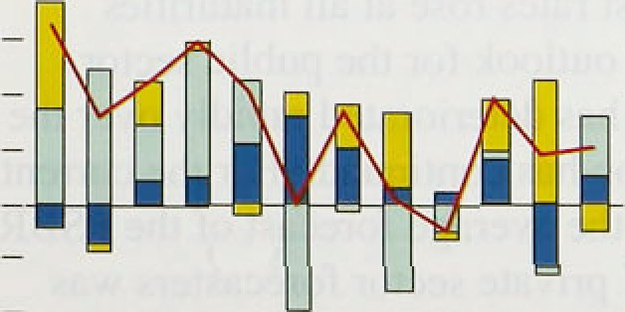

— 2'

###### ! ; â yd their net horrowing by £2.5 billion and

bp‹iu‹. »i , .3..cbiJ1ion respectively, while the flow of net borrowing Atl49 -›iii g nalsector fell by £5.5 billion. Excluding

.'»'tai›tj:oipUsorqi@hvsie''s«*. P« s° oai •u:»' netr•coursc



level since 1980. A large proportion of this .reduc,tion! was the result o.f lower borrowing .for house .purchase, which fell by £2.S billion to £3.2 billion. The:fall in borrowing for house purchase can partly be explained by purchases being brought forward to the third quarter, prior to the ending of the stamp duty holiday in August. Households’ consumption-related boi iowing was also very low in the fourth quarter.







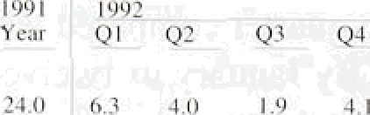



f Hurn›n%iig 1.4 -O.8 t.fi - 1.4 t.3

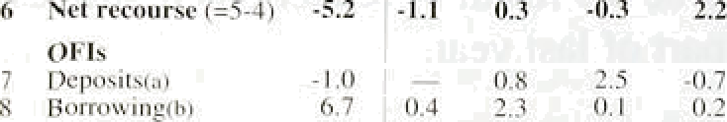



ICCs boi’rowed E1.3 billion from banks and building societies in the fourth quarter ;ifter repaying £1.4 billion of debt in the previous quarter. The pattern of monthly credit flows suggests that this largel.y reflected substantial borrowing in October (following a substantial fall in the third quarter), offset slightly by net repayments in November and December. ICCs’

boi rowing may have been int)uenced by tensions in the financial markets prior to stei ling’s withdrawal from the ERM. The increase in borrowing in October may therefore reflect the unwinding of portfolio shifts and financial i’etrenchment undertaken .in the previous quarter—or simply a shift from borrowing in foreign currency. The rise in sterling borrowing, and the accompanying fall in sterling deposits, were approximately matched by opposite movements in foreign currency borrowing and deposits. Net sterling capital issues by ICCs in the fourth quarter were low at

£1.8 billion.

Borrowing by OFIs remained extremely subdued in the fourth quarter. They did, however.. reduce their deposits by £0.7 billion, contrasting with a substantial increase in the third quarter.



The level of i.nteresi rates!that. is anticipated in the .future depends upon fiscal policy because sustained'h.igh budget deficits, may have implications for future . monetary policy. .Fol.lowi.rig.tire Autumn! Staterrient in

November 1992 intérest rates rose.‘at a!l maturi!ties: • above eight years. The outlook!for.the public sector

borrowing requirement has d'eteriorated rapid!ly ovér the past,yeai‘ as the .recession has continued. For the current fiscal. year I.592/93—the dverage\fore:cast.o.f the **PSBR** ’ma‹ie .by a sample of 37 private sñctor fprecasters was almost b}/2 o of GDP,’wh!ch; excluding privatisatiofi recei.pts, amounted„to around 7'/*9a: of GDP.. In the year 1993/94.the **PSB.R** exCluding! privatisation .recei.pts.inay well, be. higher. **.Deficits on** this **scale** would imply an iricreasing ratio of publié debt to **GDP,** : If.sustained,



Gmeral goveroraeot Daaaces

I989/P0 t9P0/9) I99J/P2 t992f93 ‹» 300.8 217.4 235.9 260-8

Q*Wick›tew

Rcbeipls 307t4 2l7/9 22!.9 z23:1 rocrket and:overseas



-7.9 -d.5 l3.8 37.0

Privatisation pmceeds 4,a S/3 ?.9 :8.0

there would be a choice between reducing the budget deficit or increasing monetary growth, and hence inflation, to lower the real burden of debt.

The extent to which the PSBR is, at present, ‘structural’ rather than ‘cyclical’ is very uncertain. Undoubtedly there are elements of both. There is a substantial cyclical component to the PSBR because of the sensitivity of both receipts and expenditures to changes in the level of activity. Tax receipts, in particUlar, vary considerably as incomes and prices change, without any discretionary

changes in taK rates. And the increase in unemployment

of over 300,000 since the Budget last year has added to public expenditure. These elements account for the bulk of the unanticipated increase in the PSBR over the past

**year.**

The New Control Total (NCT) announced in the Autumn Statement was designed to distinguish more accurately between items of expenditure which are responsive to the level of activity without any discretionary change in policy—in particular, unemployment benefit and income support paid to non-pensioners—and those which are not. As Table 3.C shows, the NCT has risen

prooeeclc —3.7







•L9 2j;7 45.0



significantly in recent years—both in monetary terms and as a proportion of nominal GDP—lending support to the view that the fiscal stance has eased.

###### Any attempt to distinguish between 'structural’ and ’cyclical’ components of the budget deficit requires some estimate of the deficit that would result if the economy were growing steadily at its underlying trend growth rate of productive potential. But there is in fact no clear distinction between cyclical and trend growth rates-they are interdependent. There is, therefore, real uncertainty about the size of the current output gap (which is discussed in more detail below). A large output gap implies that the budget deCeit could fall sharply as recovery takes place; a small output gap means that the current fiscal stance is inconsistent

with a stable ratio of public debt to GDP even in the long run.



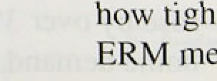

t **vienfitarypolicy** was:during **ltte.period of**

liip. This‘is evident in tfie continuing

Infl*ati‹›n Re{x›rt. February I yy1

recession, which has exceeded all but the gloomiest projections. Domestic demand fell by 3.99c between the second quarter of 1990.and the third quarter of 1992.



Total output fell by slightly more (4.2 ), even excluding North Sea production (4.0%)(see Chart 3.5).

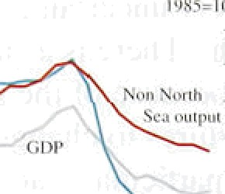— l t6





Despite the easing of policy since September, deman‹i and output have shown few signs of recovery. The trend in retail sales is upward, with a rise of 0.3% in the fourth quarter. But the most recent figures showed.a surprisingly large fall of 0.7% in December, despite a sharp recovery in sales post-Christmas among large retailers. The pattern of sales shows continuing increases in purchases of small-value items (perhaps fn response to discounting) but.no recovery in higher-value purchases. This pattern .is consistent with both the sharp recovery in MO and the evidence of weak consumer borrowing (from both consumer credit data and bank and building society lending more generally). The one exception appears to be car purchases, which have been buoyant—with registrations in January more than 7%. higher than a year earlier, according to figures from the Society of Motor Manufacturers and Traders.

The general weakness in demand in the fourth quarter is also suggested by the sharp slowdown in the rate of growth of import volumes in the past three months.

After rising by over 9% at an annual rate in the first half of the year, non-oil import volumes (excluding erratics) rose by only l *%* .in the third quarter, and remained. broadly flat in the final quarter of the year. While this may partly be a response to initial rises in import prices, survey and anecdotal evidence suggests that domestic orders have slowed, and in particular that destocking has proceeded at a more rapid.rate than before.

Output data confirm the general picture of weak activity in the fourth quarter. Although industrial output increased by over l &o in.October, this reflected a boost to energy output, and was largély reverséd In November. Manufacturing. output fell i!n. November,.and in the three months to November averaged 0.5&o less than in the previous three months. Most .of the weakness came in the consumer goolds sector, but output of investment goods also remai!ned flat.. The fall. in inanufacturifig output was particularly.disappointing after the recover in‘the first.half of. the year. and given the,continui 'ng grovwth ifi export..voluines. **.Excluding** erratics; non-oil export volumes ros‹i.by over 3% in.the. latest **Jiuee**

months over.the previous three. Manufacttlring exports



ho.m.a,demand. ’



Chart 3.6

Survey data on business and consumer optimism

CBI industrial trends survey

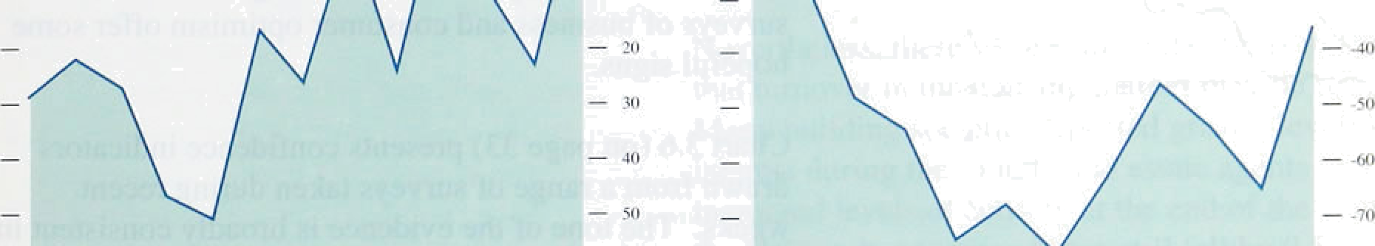



Ql Qa q; CH Ol 92 Q3 O# Ol Q2 Qa Q|

le9n 9t 92 OJ

CBI/Coopers and Lybrand Deloitte



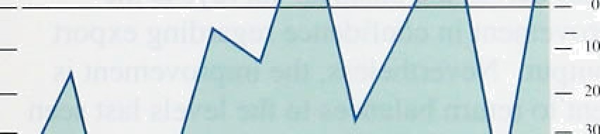

Building emplo1'ers’ confederation







Dun and Bradstreet



_ '%

Q2 Qz

91 91

British Chambers of Commerce

Indices of consumer confidence









}nlJotion Retry: Febnltiry ) fi93

Chart 1.7

Personal sector gearing







###### Taken together the latest demand and output data suggest that total domestic output is unlikely.to have risen by much in the fourth quarter, and.may even have declined. Excluding North Sea production the likelihood is that output fell slightly.

*(b ) Survey data*

It is improbable that a policy easing would have much effect within one quarter; rather the impact would be spread over many quarters. In this regard the latest surveys of business and consumer optimism offer some hopeful signs.

Chart 3.6 {on page 33) presents confidence indicators drawn from a range of surveys taken during recent weeks. The tone of the evidence is broadly consistent in suggesting that demand and output are likely to recover in the next three months. Among business surveys the

sharpest improvement is to be seen in the Januar CBI



Chart 3.8

Corporate sector gearing

survey, which showed the largest turnround ever tn the balance of firms reporting themselves more optimistic than four months ago (from -23&o in October to +11&o in January). There have been sñnilar recoveries in all of the other business surveys. A further, unsurprising, common factor across the business surveys is the marked improvement in confidence regarding export orders and output, Nevertheless, the improvement is only sufficient to return balances to the levels last seen at the beginning of 1992.

There have also been recoveries in consumer confidence recorded in both the Mori and Gallup surveys. Both have improved substantii:l:1y from low points in October

*•• q (the former by rather more, although the series tends anyway to be more volatile), but not yet to the.levels

“ seen in the second quarter of 1992.

- 30



- — 20



# — °



1. *Debt and gearing*

High debt levels continue to have an impact on the financial dgcisions of hps the personal and corporate sectors. Recent cuts in interest rates have. lowered income geari.rig (tire:ratio.of interest payments.to disposable income). i.n both. sectors,. and wi11!thusiiave eased ttie constraints o;n borrowers (nice Charts 3.7 and

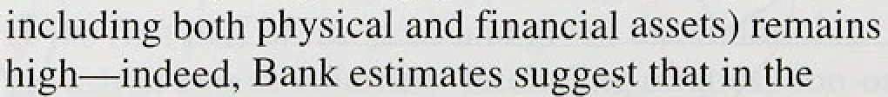

.personal seitor'it mas continued ti›.r o as housQ pricas:







revised downwards, then individuals may take

ildvantage of interest rate cuts to pay off debt and IROVC

towards their desired levels of gearing. Since, to date, new borrowing has been flat, and repayments high, it seems that the personal sector is still in the process of adjusting towards a lower gearing level. Present, and prospective, falls in house prices are clearly acting as a constraint on personal sector borrowing, as is the scale of negative equity, which is now thought to affect over

* 1. million households.(

Nevertheless, there were some indications in December that turnover in the housing market may be recovering. Many building societies reported greater levels of interest during the month, and estate agents reported increased levels of activity at the end of the year. Bl2t the Halifax house price index still fell by 0.5% in the month (and a further 0.4% in January), and with a substantial overhang of vacant properties it may be some time before increased turnover levels are translated into house price increases. The experience of significant falls in nominal house prices may also lead many households to revise their view of the riskiness of housing—especially when highly geared—as an investment. A change in expectations of this kind would have a permanent effect on the level of house prices.

*(d } The outp• ! 8*P*

Although inflation is a monetary phenomenon, the transmission of changes in monetary policy to inflation is partly effected through changes in demand and output. Of itself the change in output may not be an accurate leading indicator of inflation. Rather, it is the gap between actual and potential output which is of interest. Potential output is defined as that level of output, consistent with stable inflation, where all productive factors are being used efficiently. It is an economic rather than an engineering concept, and can differ from the physical maximum that can be produced frorri the nation’s capital stock. The difference between potential and actual output at any given moment, the ‘output gap’, is a measure of the degree to which changes in demand can readily be absorbed by pindacers and is thus an indicator of inflationary

Tti6re is little doubt that tire economy is operating below potential at tlie moment, and that there is downward

Inflation Reprint: February l •H3

pressure on inflation from that source as a result. But measuring the size of the output gap is not straightforward. One measure is provided by responses to the CBI Industrial Trends survey. Chan 3.9 shows the percentage of firms reported as working below capacity. It clearly indicates that the utilisation rate is lower than at any time since the early 1980s although not as low as at the depth of the previous recession.

After levelling off in 1991, the utilisation rate actually increased a little in 1992, but has since fallen back



again—to its lowest level since 1983.



— 7(l





Another common method of estimating potential output is to identify similar points in the business cycle and assume that potential output grew at the average

rate of output growth over the intervening periods. The points of similar activity are usually selected by examining survey evidence on utilisation levels, .order books, leading indicators, expectations and the like.

Peak to peak, and trough to trough, output growth measures are examples of the approach. This ‘straight line’ method sees potential output growth as determined largely by technical progress which continues at a more or less constant rate, independently of short-term developments in the real economy.

Using this method it is estimated that trend growth between the cyclical peaks of the second quarter of 1979 and the third quarter of 1990 was 2'/i& per year. If output growth was on trend at the end of 1990, this would imply that the output gap was currently around 79c.

Other methods assume that potential output is not.a function of eKogenous technical progress alone, but that current economic conditions influence the rate of investment in more productive capital. This implies a rather different view of long-term growth prospects. In this approach de.mand will affect supply through

capital scrapping and the deterigration of the quality of the labour force so that prolonged periods of underutilisation would adversely affect Je quality of productive inputs, in turn lowering tlie gr9Wth of productive potential. Jf the growth of potential in .the current recession has behaved in a way similar to that experienced i.n tire. early l980s.then..the ou@ut:.gap.on this methodology could be rather less than the



###### Chart t.ie

tlneraployment rate



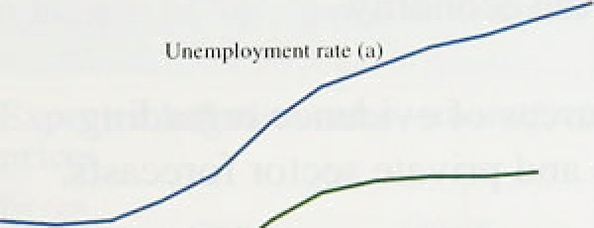



(•) As e pcyportieti of tnia ortfom



4 ne o e nd t e bo e

The output gap provides an indicator of the degree of inflationary pressure in goods and services markets. The unemployment rate provides a similar indicator for the labour market. The level of unemployment is an

indicator of excess supply in the labour market. The

change in unemployment may also exert an influence on earnings. The rise in unemployment over the course of the recession has undoubtedly contributed to the slowdown in nominal earnings gyowth, and the recent acceleration in labour shedding would also be expected to restrain earnings growth. But the long-

term unemployed exert less of a downward effect per capita on wages than the numbers unemployed for less than twelve months, because those who have been out of work for a long time become generally less employable. Chart 3.10 shows that, while total unemployment has continued to rise, the level excluding the long-term unemployed has broadly flattened off, suggesting that the impact on earnings from excess supply in the labour market might not increase any further and could diminish.

The behaviour of wages will have an important influence on the rate at which sterling depreciation feeds through to the domestic price level. In the long term if the nominal depreciation that has occurred since late September persists, and is accommodated by monetary policy, then the domestic price level will be higher—by the same proportion as the depreciation— than it would have been in the absence of depreciation. But the path along which prices adjust to this long-run outcome depends upon the response of domestic factor incomes. The initial impact of a nominal depreciation is a deterioration in the terms of trade. This implies that in the short run either (i) real wages and/or real profits will fall, or (ii) domestic prices will rise, offsetting the depreciation and restoring the terms of trade to their previous level, or (iii) some combination

of(i) and (ii). If inflation is to remain within its target range the brunt of the adjustment will have to come frorp the first of these alternatives. And if real wages for those in employment continue to grow as rapidly as they.have since the recession began (see Chart 2.5)

, iilihe adjustment will take the form of rising

Unit labour costs have been rising if at all, in recent months. If this

*ot* sterling depreciation

Inflatic'n Report: February I fi91

flat because of smaller increases in nominal earnings rather than further labour shedding.

3 5 E ectat o o at on

One indicator of the success of policy is the extent to which expectations of inflation are reduced. The more convinced the private sector is of the authorities' intention to resist inflation the more rapidly will expectations adjust, and the less costly (in terms of lost output) will be the adjustment process. Knowledge of the private sector’s expectations of inflation is an essential component in forming a judgement of the likely future course of the economy.

There are two main sources of evidence regarding expectations—surveys and private sector forecasts.

*( n ) Curve y evidence*

The accompanying box presents latest evidence from a number of well-known surveys of price expectations. All o( the suTxeys suggest that, by past standards,

expectations of inflation remain low. But there are signs of an increase in most expectations since sterling’s departure from the ERM. The most compelling evidence comes from the CBI Industrial Trends Survey, which has been in existence long enough to permit statistical analysis of its information content with respect to published price indices. As it surveys mainly the manufacturing sector it is also likely to highlight the impact of depreciation more rapidly than the other surveys—and in both October and January the number of respondents expecting to increase prices in the next

four months has risen. The sharp increase between

October and January .should be qualified by the observable seasonal pattern in the survey responses (associated with the changing of list prices in January). The seasonally adjusted balance is estimated to have risen from -5 to 0, suggesting that output price inflation is likely to rise—but not Very rapidly.

The Barclays/NOP and **Smith** New **Court** surveys relate to expected RPI inflation. 'The former has shown .large implied ewors at both the.one and two-year horizons.

By coiitrast the:Smith New Co rt survey offers:a.clear indication of.the upward.revision to inflation expectations which hals followed tire suspension!of ERM membershi pproxmately !/ ,I percentage point.

**But. the sample from ñl ch. the..iurvey.is drawn is small,.**

and may be ,unrepresentative.





Surveys.of **inflati‹in expectations**

There!is. a growing. **academic** literature on the..use.and interpnitation of:siirveys. This parallels..the in‹iréasiiig

!ñumber of business and coñsiimer suiveys now bein undertaken, many of which provide information. pn iñflation expectations. At present the surveys offer a mixed ,pietuiei. ofeñpected mov.einents!:of inflation  'months.

:quarteély ' suiveys of iiiflation expectations for the. general public.as ;well!as a:number:of seller groups.(such’81.

.- investment analy.sts;' business econoinists.and others)'.. The.

l'986 and provides inflation expéctations on:e and two'years ahead. On: average,.the.general public have not pr.edicteld.'inflatlofi accurately.. The mean .absolute errñr of one-year..ahcad

The

One of.the'oIdest.and best-knonn bitsiness suryey.s:is.the: two-..year ahead forec.ast errfir is slightly higher.. While .the

w.elf

am evaluation'of inaniifaiiturets *cur.*reiit.::'outpUti.OfdefSi predicted, expectations havei since.followe,d:inflation down

.trade, capital:spending, etc: I!ii addition,.the survey: contains' with a considerable lag, The.public’s latest.expectations nf

*pecia/io*itr *of* key variables,.S.uch..as prices:and otlIpUt''f0f. inflation .for 1994 were. made. in Dece.mber and.remain the coñiing.four..months '. Expe;statidns. are.defined in aboe the official target range, at 5.2&o.

qualitative-terms; that:iis;.survey. .respondents:indicate

whether the.trend‘in their prices: over the iiext four months ' is.likelj to bé 'up', ‘down' or to remain! the ‘same’.

Expected inflation rates—nianul’aclurers’ domestic

prices

CSO CB I U P 

The *Galluf›/EC Consumer Confidence Suryay* is a monthly survey of around 2,000 individuals. It: provides the raw responses in terms of whether respondents expect over the next 12 months that prices will (i) increase as › roster rate

(ii) increase at the same. rate (iii) increase at a slower rate

(iv) remain stable (v) fa)l slightly.. Weighting these responses together (with weights of 1,. 0.5,. 0, -0.5, - I ) produces the summary index shown in the chari betow.

annualised

. I99T QJ 7.7

Q2 7.3

Q4 2.7

1992 Q l 5.3

g2 4.5



annualised

36

21 6.4

3.1

18

12 i i

22

This suggests that expectations of inflation one year ahead have been on a downward, albeit erratic, trend during this recession along with actual inflation, reaching a low point last August. Following increases in September and October the most recent surveys show turiher slip•ht declines.

Smith *Nez- Court/Galluy* produce a monthly survey of around 100 fund managers. Since August 199 l it has

where Q I = Jan.—April. Q2 = Apñl—July: Q3 = July—ori.. Q4 = Ski.—Jan.

. Research in the Bank,suggests that CB I survey expectations liave provided additional information on producer price i'nflation.’in the pit 10 yeâm—over'and above that contained in.the past:histoJ.‘of inflation.. Predictions from an eqiiattoh—using only the UP responses, rather than the balances.which!ari conventiorially quoted:—closely follow the gradual..decline inl thé (four-rrioñth)..inflation rate .over the past two years. But the anticip'ation .in both the October and Janu@ surveys. is .consistent'with an increase in

included a question on expectations of RPI inflation for end- 1992 and since June 1992 a question has atso been included on inflation expectations for end- 1993. Until sterling’s suspension from the ERM, expectations for inflation for end- 1992 and end- 1993 were revised almost continually downwards in line with the current inflation rate. Since Septeriiber expectations have been revised upwards, the decline in sterling. apparently adding

*'lv* l percentage point to inflation expectations for end-1993.

predicted inf1;atiod in ment ind ciiiñing riionths. . Dun and Bradstreet Su rears un expect:ilions ‹if selling

prices and €iallup consumer tirice expertittions

The *Dun,and Bradstr..e et Survey* has.been in existence since „,

the .fourth quarter of 1987. The:!question..rim pri'cgs asks!.the (b.usiness) inteviewees whether they expéét'théir sel!ling

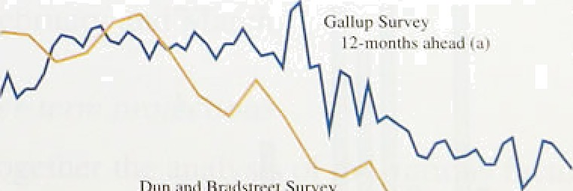

prices..to increase, decline or'remain unchange‹i over thai —

, ñe t ttiree:months con:pared. witli 12. months.earlier. The _ pspgl:riumber of responses is around 2;00Wabout 209b of

those wlifi. are sent fornis. —

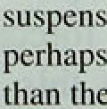

B9 90

.fgi Weighted a›cmgc 0f responds io 'Gallup question.



* • tb}'Bnlencc of ihusc expecting an incma.w t+ i or a dccrca. (- i irr ,ch ing prices.



lnl«GonRgpou: Fchn ' 1993

Chart 3.1 I

Distritiulion of pri›'ate sect‹ir forecasts fur inflation in 1993 Q4

*(b } Outside fr›recâs!ts*

Further evidence on inflation expectations is available from forecasts undertaken by private sector institutions. The charts below present projections for underlying inflation in the year to the fourth quarter of 1993 and the fourth quarteT Of 1994. These wete made by 37 different organisations including City firms and academic forecasts such as those of the London Business School and the National Institute.



The progress on costs and the relatively long lags from

* • policy to demand, output and inflation mean that around

half of the forecasters currently.envisage underlying

* • inflation remaining at or below 4& for the remainder of

this year. But it is noteworthy that only 11 out of 37

- , expect to see further downward progress from December’s level (see Chan 3.11). And only 12 out of

_ 37 expect underlying inflation to be at or below 4Ra ht

the end of next year (Chart 3.12).

The anticipated increase in inflation in these forelcasts partly reflects underlying assumptions that interest rates are likely to fall further, and that sterling will depreciate. These forecasts suggest that sufficient credibility does not yet attach to the inflation objective announced in

.October fpr many forecasters to be confident that the

objective will be achieved within two years.

Chan 3.12

Disl ribution of private sector forecasts for inflation in 1994 Q4

3 6 l o a

The lags between changes in .interest rates,and their effect on inflation are sufficiently long that.it is necessary to form a judgement on the tiiind in i!nflation over the next two years or so, eondi.tional’ on..existing rates and other policies. Forecasts of.inflation over such. time .horizons are notoriously inaccurate. It would, therefore, be unwise to basé policy on,;he wholly spurious precision. of a ppint forecast,

09 )5 21 3.7 3.3 3.9 i5 51 17 6.J

‹ Given the random shocks.tbat,hit the economy, forecasts

###### will never be precisely accurate. Their value lies hot ifi

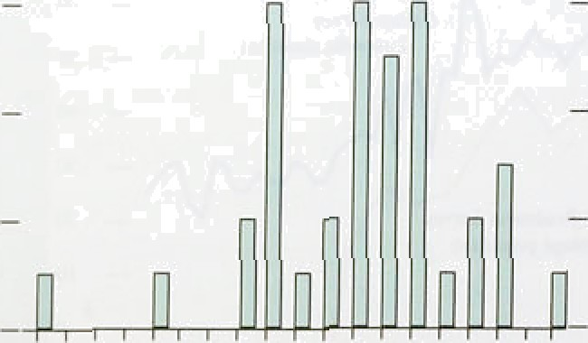

_

, their powers of prediction. Rather they’are guiilepoits

against which.future.developments in the economy may

, be evaludtfid. .When. the/outturn differs s»m ae forecast it is..important„to:.ask what ‘news’ ‘is conveyed by this. diffefencg. The citalia siiown below should be seen in





1. *Short-run projections*

Month-to-month changes in RPIX can be predicted with some confidence over a very short-term horizon by extrapolating its past behaviour. Combining the projected monthly change with eleven months of known outcomes produces a forecast for the annual RPIX inflation rate which is usually fairly reliable for a month or two ahead. Inflation forecasts beyond this very short horizon become increasingly uncertain, as the monthly change is more likely to be affected by behavioural factors (not accounted for in simple extrapolation) and as the known history in the forecast twelve-month measure declines.

Chsrt 3.13

**RPIX inflation projections** and outturns

Pcrecalog* changes en a ycsr earlier

6.0







Short-term projections based on this approach, augmenting extrapolation of past trends with specific adjustments incorporated for known prospective changes in administered prices and for the estimated

pass-through of the depreciation of sterling, are shown in Chart 3.13,(1) The chart also displays the equivalent projection made in October, together with the typical margin of error on both forecasts, determined by the

average errors made on such projections in the past. The chart illustrates the extent to which the slowdown in the rate of growth of RPIX was underestimated towards the end of last year. Given the relatively mechanical nature of the projections this indicates that RPIX growth

slowed in relation to its past trend—although it is not clear whether this was the result of temporary shocks, or a more fundamental change in economic conditions.

The weakness of demand and output in the fourth quarter points to the conclusion that underlying inflationary pressures were continuing to weaken as a result of the tight monetary stance prior to departure from the ERM.

The latest projections show a further fall in underlying inflation in January, followed by a slight increase, to 3.5&o, in February and March.

*(b j Longer-term projections*

Drawing together the analysis of the various factors that influence inHation, it is possible to form a judgement

f. , about the prospects for inflation on the basis of present policies (interest rates and the fiscal position) and assumptions about the world economy.

Chart3.1A **sltows** Bank prqjections for inBation in the



## The green pound and inflation

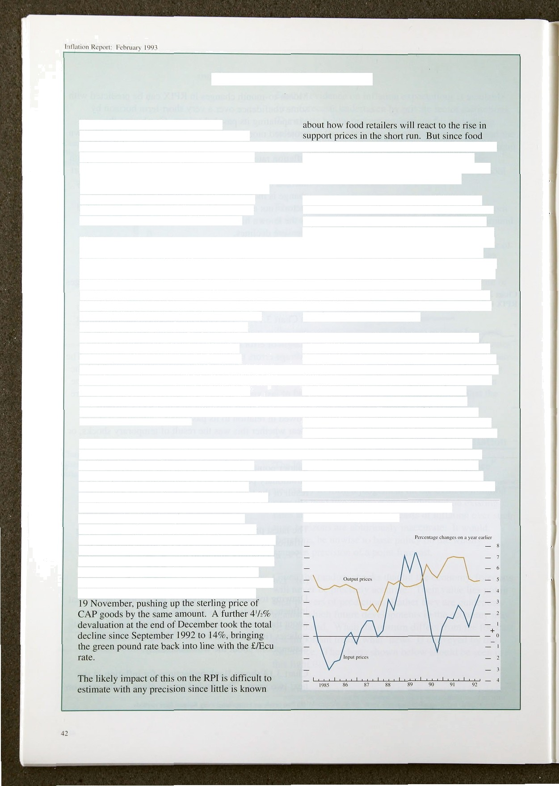

The green pound is the rate at which Europe-wide agricultural support prices are

converted from ecus to sterling. Until recently, the rate was set administratively once a year. when it was brought into line with market rates if necessary. During the period that sterling was in the ERM, the discrepancy with market rates was never p•reat. However, sterIing’s devaluation initially opened up a 14'/who gap between the green pound rate and the official ecu rate.

This gap would normally represent a windfall gain for UK farmers, **since** Ecu farm prices expressed in sterling will have risen. However, the common agricultural policy is intended to ensure a uniform set of agricultural prices across all agricultural products for all member nations. Until recently, a complicated system of ‘monetary compensation amounts’ (MCAs) existed to eliminate relative price changes resulting from exchange rate movements. In the event of a devaluation, the increase in domestic prices was offset by

imposing equivalent taxes on exports and subsidies on imports, the proceeds of which were passed on as compensation to foreign importers of domestic agricultural produce and domestic importers of foreign produce. These taxes and subsidies remained in place until the green pound was restored to marker rates.

However, this system disappeared in January with the advent of the single market and the abolition of all border levies. The green pound will in future be adjusted at least once a month. while MCAs disappear altogether. Because these prospective arrangements were well known, this meant that during November and December **1992,** the change in administrative arrangements appeared to offer scope for speculation, since exporters could import food stuffs from elsewhere in the EC in November (and receive a subsidy for doing so) and subsequently re-export at a profit in January once export levies were removed. To **discourage** this the green pound was devalued by 3&o in September and by an additional 7% on

accounts for 159b of the RPI, and around one fifth of this is accounted for by spending on CAP foods, the maximum initial impact of a l3&a rise in prices would be 0.4 percentage points.

The total effect might be reduced if importers, manufacturers and retailers absorbed some of the increase in their own margins. Food, drink and tobacco prices have grown slowly in the past few months—just 0.9% in the fourth quarter despite a 2.8% increase in input prices—suggesting that some squeeze in margins may be under way. And given that output prices in this sector have largely outstripped input prices since 1985 (see chart) there may be scope for still further declines. On this basis the net impact of 0.4 percentage points may be at the top of the range.

But there may well be additional effects from other ERM realignments, most recently the 10a depreciation of the Irish punt. This is because the so-called ‘switchover’ or 'strong currency’ system remains in place. Under the rules of this system, the ‘green ecu’ is revalued in line with the strongest currency whenever an individual currency realigns. This is to mitigate income losses suffered by farmers in the strong currency country forced to revalue. These switchover rules mean that the green pound will be devalued slightly against the green ecu as a result of the punt’s devaluation, though it is unlikely to be much larger than 2%. The resulting additional impact on food prices is unlikely to be very large.

**Inflation in the food, drink end tobacco manufacturing industries**

Cbart3.14

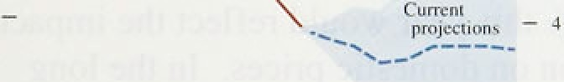

- O



inflation projections made since 1985: at the one-year horizon it is approximately l'/ percentage points (broadly in line with the errors reported by the Treasury in the Pinancial Statement and Budget Report); at the two-year horizon it is around 2'/› percentage points.

While these errors may appear very large, they reflect the impact of a wide range of unexpected events which can have a significant and rapid effect on inflation.

Most important of these are changes in world prices (especially oil prices), and the effect of large and sudden movements in exchange rates.

Over the next two years, in the absence of major shocks, and given a broadly unchanged policy stance, inflation may fall a little from the rate at the end of 1992- The easing of policy which has already occurred is consistent with this prospect although it will undoubtedly slow the progress on inflation which was in train. Demand conditions remain relatively depressed—notwithstanding the indications from MW and the recovery which may occur this year is unlikely to be rapid in its initial phase, not least because of the continuing weakness of world demand. There has already been some pass-through of the depreciation to input and import prices, but the scale of the output gap and the level of unemployment—both of which are likely to increase this year uggest that nominal wage increases should decline further, and profit margins remain subdued.

The central projection for inflation is in the 3 *—4&o r*an*ge.* But it is clearly well within the margin of past errors that the inflation target could be breached in either direction, more probably on the up-side. The forces which have contributed to the unexpected weakness of demand over the past two years—in particular levels of debt and gearing, and the problems of financial fragility will continue to exert some downward pressure on inflation. But a more rapid

pass-through of sterling depreciation than expected, or a sustained further sterling depreciation, could lead to a rate of inflation above the top of the target range.



' g¥ t}gii coli. I*.iit'{ jfzoyt l1• *tl•i I In t i' i i i . i

 

When the Chancellor commissioned the Inflation Report in his Mansion House speech on 29 October 1992, he said that its aim was to ‘provide a regular report on .the progress being made towards the Government’s inflation objective’. The inflation target is a range of I %—4% for the rate of increase of **RPIX.** Inflation has now been within this range for three months, the first time it has been below 4& for over five years. In the short run it is possible that inflation will exceed the top of the target range during calendar 1993, but it is more likely that inflation will remain in the 3%—4% range in the absence of any unexpected shocks.

An outcome above 4% this year would reflect the impact of sterling depreciation on domestic prices. In the long run, competitiveness depends on real factors such as profit rates and real wages, and not on the nominal exchange rate. Hence a lower nominal exchange rate implies higher domestic prices than would otherwise have been the case. The qualification is important.

Depreciation does not necessarily .imply that inflation will rise, merely that it will be higher than would have been the case had monetary policy validated the higher exchange rate. The response of wage settlements and earnings to the impact of higher import prices matters because it affects the timing of the pass-through from depreciation to domestic prices. If labour costs and profit margins rise to offset the effect.of depreciation then retail prices will rise more rapidly than now looks likely. This would mean that underlying inflation might temporarily lie outside the target range.

The principal policy .instrument for keeping inflation within its target range is monetary policy. Because there are significant lags. between changes i!n. interest.rates and their impact on inflation—of the order of one to two years or even longer—it is important to focus on trends

i.n inflation over the same.period. The inflatiqn outlook. for.1994 and beyonñ. depends on!the balance between.the continui.ng downward pressure on.i!nfl’ation resulting from the difference between actual an‹i.potential, output—reflected i'n ri'sing unemployment. and, ihe stimulus to inflation from past sterling depreciaaon and fettrs: that part of the continuing fiscal deficit will

ev ntually be monetiaed. The balance of probabilities is



###### that inflation will be slightly lower in 1994 than it was at the end of 1992. The main risks to this prospect come from the possibility of a sustained further depreciation of sterling and a faster pass-through of the depreciation that has already taken place. There is also a risk that large fiscal deficits might create expectations of higher inflation in the future.

It is important to stress that expectations of inflation have not yet adjusted to levels compatible with a target range for inflation of l la—4&•. Such a target range would mean that at this stage of the cycle inflation would be expected to be nearer l % than 4%. The reverse is the case. This demonstrates that there is still some way to go before the underlying inflation rate is consistent with the objective of price stability. Ultimate success will depend upon a medium-term monetary policy which is, and is expected to be, firmly

counter-inflationary. Expectations in financial markets,

and of wage earners and firms, have some way to adjust, and a change of expectations is required. The consistent pursuit of a counter-inflationary monetary policy will ensure that expectations do adjust, and that price stability is attained. Steady progress has been made towards achievement of the Government’s inflation objective. But further progress is required.

